1. What is Deep Learning?

If you are going for a deep learning interview, you definitely know what exactly deep learning is. However, with this question the interviewee expects you to give an in-detail answer, with an example. [Deep Learning](https://www.simplilearn.com/tutorials/deep-learning-tutorial/what-is-deep-learning) involves taking large volumes of structured or unstructured data and using complex algorithms to train neural networks. It performs complex operations to extract hidden patterns and features (for instance, distinguishing the image of a cat from that of a dog).

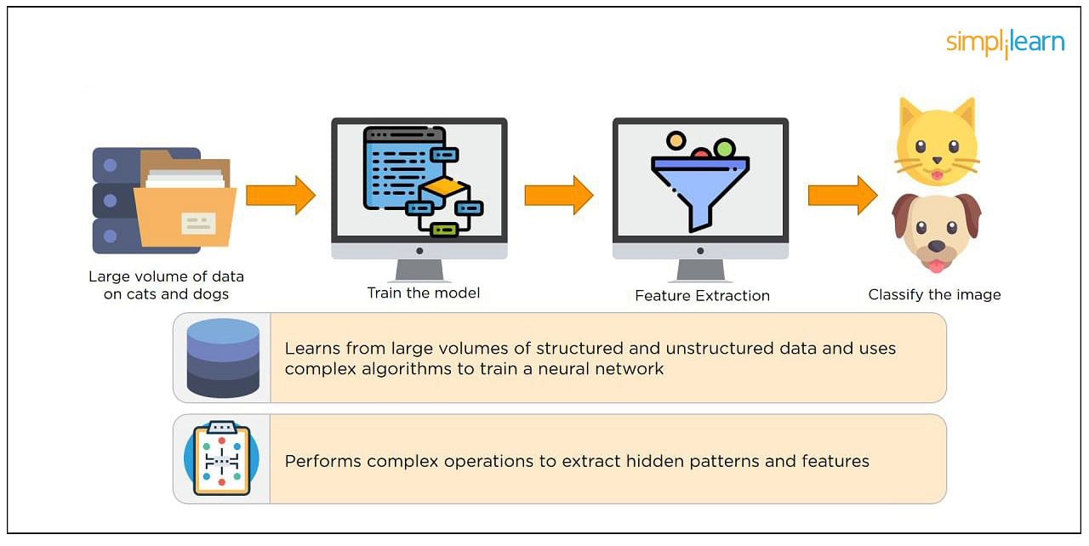

2. What is a Neural Network?

[Neural Networks](https://www.simplilearn.com/tutorials/deep-learning-tutorial/what-is-neural-network) replicate the way humans learn, inspired by how the neurons in our brains fire, only much simpler.

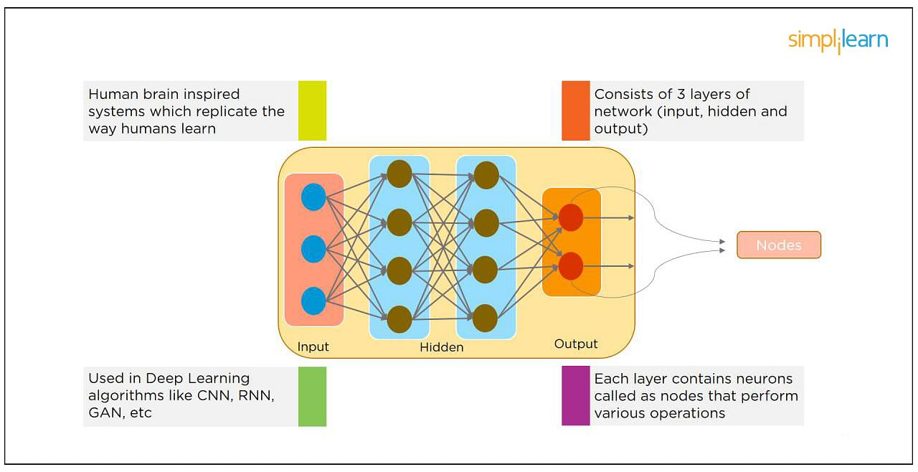

The most common Neural Networks consist of three network layers:

1. An input layer
2. A hidden layer (this is the most important layer where feature extraction takes place, and adjustments are made to train faster and function better)
3. An output layer

Each sheet contains neurons called “nodes,” performing various operations. Neural Networks are used in [deep learning algorithms](https://www.simplilearn.com/tutorials/deep-learning-tutorial/deep-learning-algorithm) like CNN, RNN, GAN, etc.

3. What Is a Multi-layer Perceptron(MLP)?

As in Neural Networks, [MLPs](https://www.simplilearn.com/tutorials/deep-learning-tutorial/multilayer-perceptron) have an input layer, a hidden layer, and an output layer. It has the same structure as a single layer [perceptron](https://www.simplilearn.com/tutorials/deep-learning-tutorial/perceptron) with one or more hidden layers. A single layer perceptron can classify only linear separable classes with binary output (0,1), but MLP can classify nonlinear classes.

Except for the input layer, each node in the other layers uses a nonlinear activation function. This means the input layers, the data coming in, and the activation function is based upon all nodes and weights being added together, producing the output. MLP uses a[supervised learning](https://www.simplilearn.com/tutorials/machine-learning-tutorial/supervised-and-unsupervised-learning) method called “backpropagation.” In backpropagation, the neural network calculates the error with the help of cost function. It propagates this error backward from where it came (adjusts the weights to train the model more accurately).

4. What Is Data Normalization, and Why Do We Need It?

The process of standardizing and reforming data is called “Data Normalization.” It’s a pre-processing step to eliminate data redundancy. Often, data comes in, and you get the same information in different formats. In these cases, you should rescale values to fit into a particular range, achieving better convergence.

5. What is the Boltzmann Machine?

One of the most basic Deep Learning models is a Boltzmann Machine, resembling a simplified version of the Multi-Layer Perceptron. This model features a visible input layer and a hidden layer -- just a two-layer neural net that makes stochastic decisions as to whether a neuron should be on or off. Nodes are connected across layers, but no two nodes of the same layer are connected.

6. What Is the Role of Activation Functions in a Neural Network?

At the most basic level, an activation function decides whether a neuron should be fired or not. It accepts the weighted sum of the inputs and bias as input to any activation function. Step function, Sigmoid, ReLU, Tanh, and Softmax are examples of activation functions.

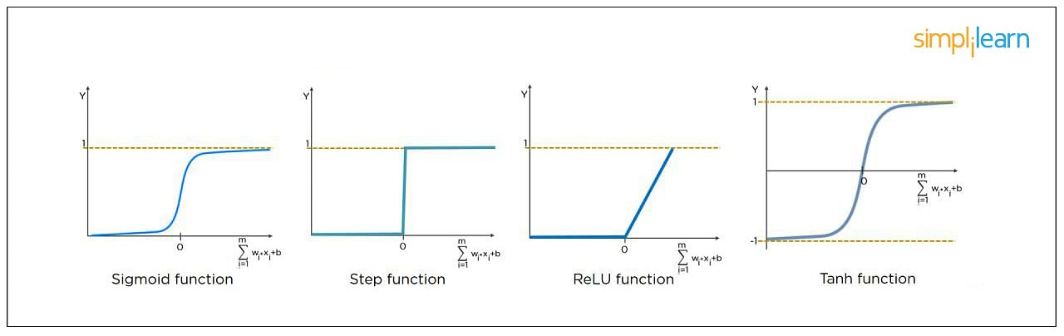

7. What Is the Cost Function?

Also referred to as “loss” or “error,” cost function is a measure to evaluate how good your model’s performance is. It’s used to compute the error of the output layer during backpropagation. We push that error backward through the neural network and use that during the different training functions.

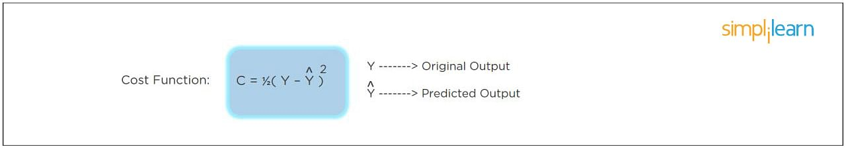

8. What Is Gradient Descent?

Gradient Descent is an optimal algorithm to minimize the cost function or to minimize an error. The aim is to find the local-global minima of a function. This determines the direction the model should take to reduce the error.

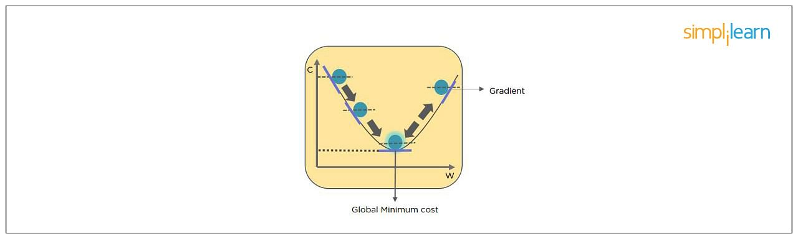

9. What Do You Understand by Backpropagation?

This is one of the most frequently asked deep learning interview questions. Backpropagation is a technique to improve the performance of the network. It backpropagates the error and updates the weights to reduce the error.

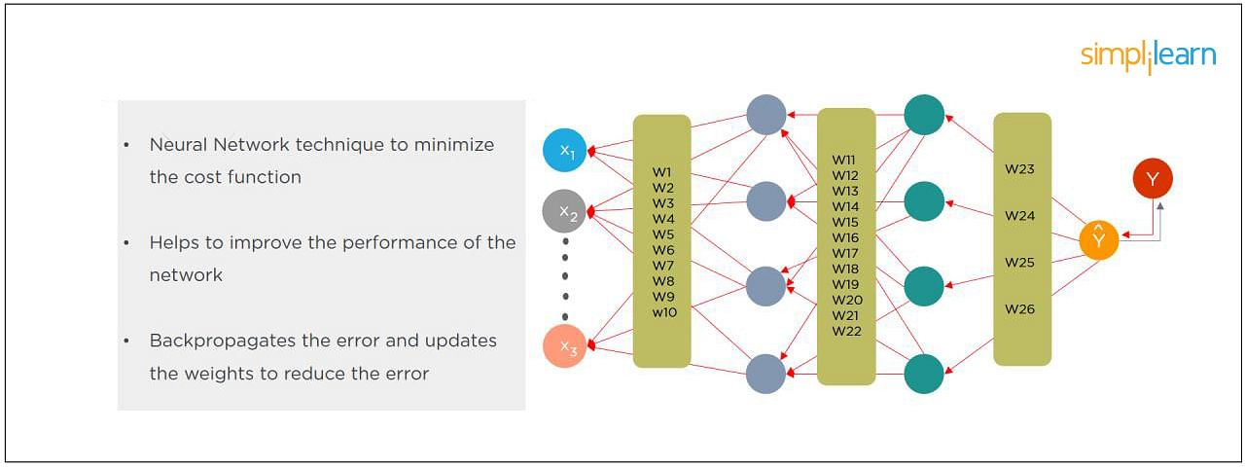

10. What Is the Difference Between a Feedforward Neural Network and Recurrent Neural Network?

In this deep learning interview question, the interviewee expects you to give a detailed answer.

A Feedforward Neural Network signals travel in one direction from input to output. There are no feedback loops; the network considers only the current input. It cannot memorize previous inputs (e.g., [CNN](https://www.simplilearn.com/tutorials/deep-learning-tutorial/convolutional-neural-network)).

A Recurrent Neural Network’s signals travel in both directions, creating a looped network. It considers the current input with the previously received inputs for generating the output of a layer and can memorize past data due to its internal memory.

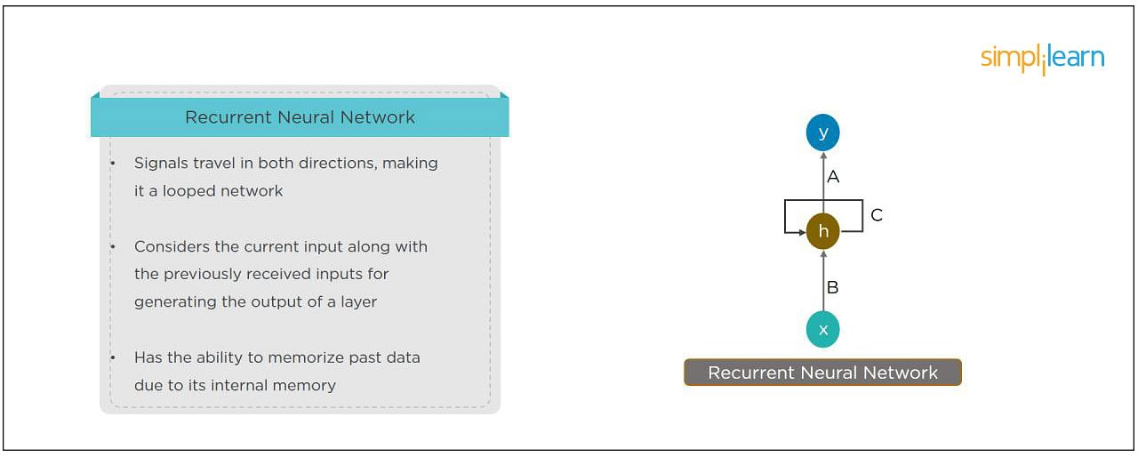

11. What Are the Applications of a Recurrent Neural Network (RNN)?

The [RNN](https://www.simplilearn.com/tutorials/deep-learning-tutorial/rnn) can be used for sentiment analysis, text mining, and image captioning. Recurrent Neural Networks can also address time series problems such as predicting the prices of stocks in a month or quarter.

12. What Are the Softmax and ReLU Functions?

Softmax is an activation function that generates the output between zero and one. It divides each output, such that the total sum of the outputs is equal to one. Softmax is often used for output layers.

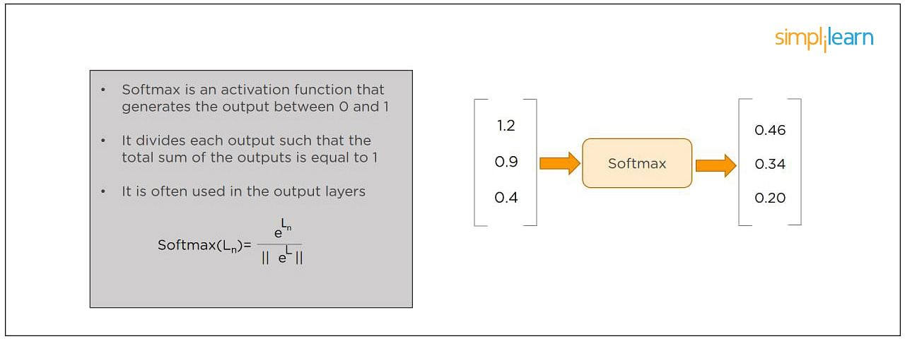

ReLU (or Rectified Linear Unit) is the most widely used activation function. It gives an output of X if X is positive and zeros otherwise. ReLU is often used for hidden layers.

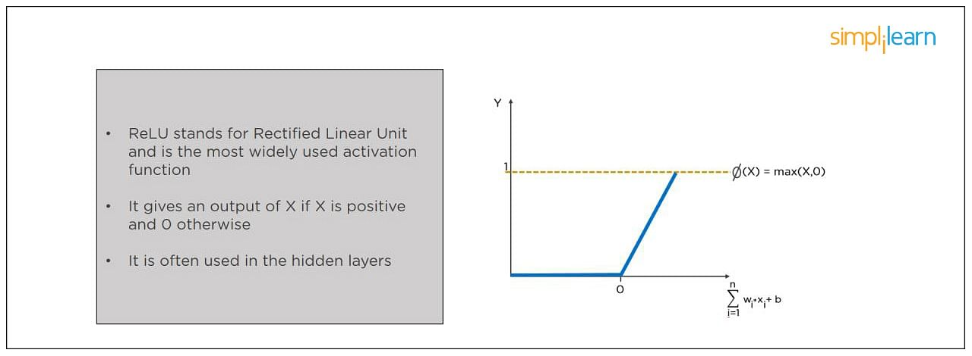

13. What Are Hyperparameters?

This is another frequently asked deep learning interview question. With neural networks, you’re usually working with hyperparameters once the data is formatted correctly. A hyperparameter is a parameter whose value is set before the learning process begins. It determines how a network is trained and the structure of the network (such as the number of hidden units, the learning rate, epochs, etc.).

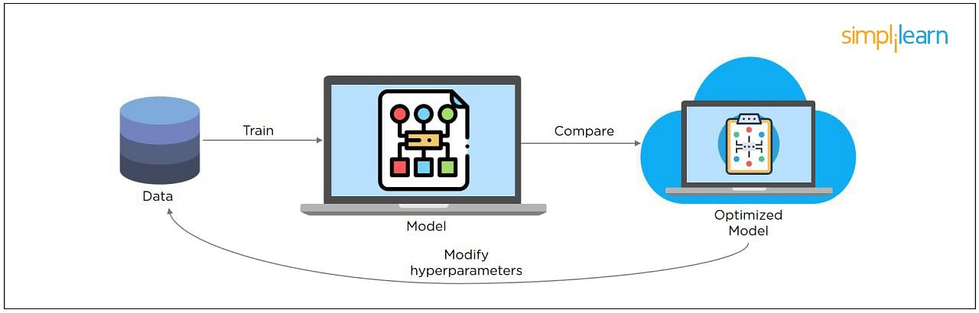

14. What Will Happen If the Learning Rate Is Set Too Low or Too High?

When your learning rate is too low, training of the model will progress very slowly as we are making minimal updates to the weights. It will take many updates before reaching the minimum point.

If the learning rate is set too high, this causes undesirable divergent behavior to the loss function due to drastic updates in weights. It may fail to converge (model can give a good output) or even diverge (data is too chaotic for the network to train).

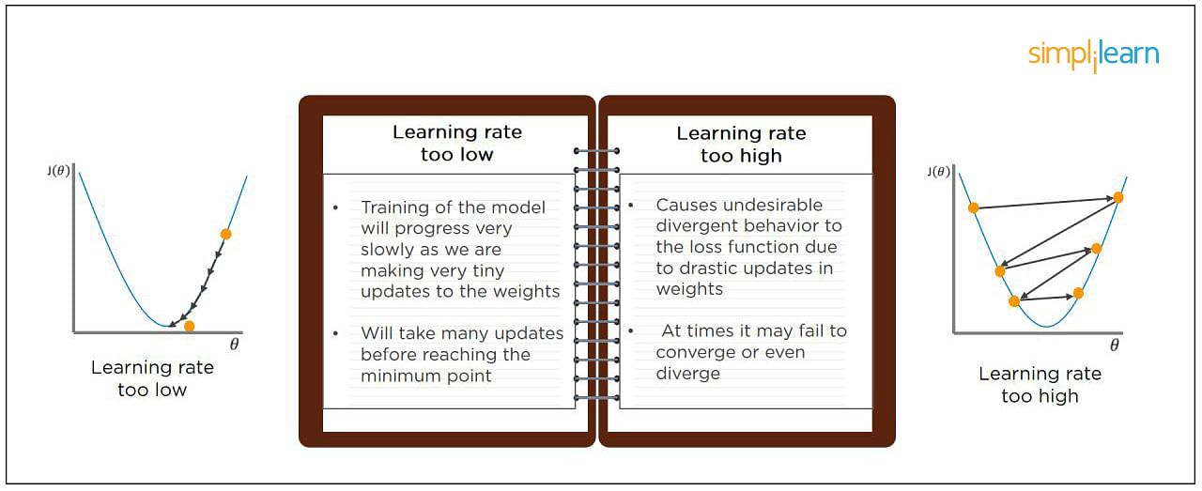

15. What Is Dropout and Batch Normalization?

Dropout is a technique of dropping out hidden and visible units of a network randomly to prevent overfitting of data (typically dropping 20 percent of the nodes). It doubles the number of iterations needed to converge the network.

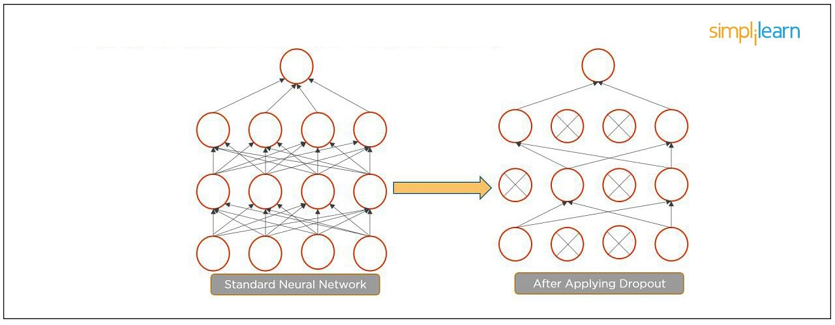

Batch normalization is the technique to improve the performance and stability of neural networks by normalizing the inputs in every layer so that they have mean output activation of zero and standard deviation of one.

The next step on this top Deep Learning interview questions and answers blog will be to discuss intermediate questions.

16. What Is the Difference Between Batch Gradient Descent and Stochastic Gradient Descent?

|  |  |
| --- | --- |
| Batch Gradient Descent | Stochastic Gradient Descent |
| The batch gradient computes the gradient using the entire dataset.  It takes time to converge because the volume of data is huge, and weights update slowly. | The stochastic gradient computes the gradient using a single sample.  It converges much faster than the batch gradient because it updates weight more frequently. |

17. What is Overfitting and Underfitting, and How to Combat Them?

Overfitting occurs when the model learns the details and noise in the training data to the degree that it adversely impacts the execution of the model on new information. It is more likely to occur with nonlinear models that have more flexibility when learning a target function. An example would be if a model is looking at cars and trucks, but only recognizes trucks that have a specific box shape. It might not be able to notice a flatbed truck because there's only a particular kind of truck it saw in training. The model performs well on training data, but not in the real world.

Underfitting alludes to a model that is neither well-trained on data nor can generalize to new information. This usually happens when there is less and incorrect data to train a model. Underfitting has both poor performance and accuracy.

To combat overfitting and underfitting, you can resample the data to estimate the model accuracy (k-fold cross-validation) and by having a validation dataset to evaluate the model.

18. How Are Weights Initialized in a Network?

There are two methods here: we can either initialize the weights to zero or assign them randomly.

Initializing all weights to 0: This makes your model similar to a linear model. All the neurons and every layer perform the same operation, giving the same output and making the deep net useless.

Initializing all weights randomly: Here, the weights are assigned randomly by initializing them very close to 0. It gives better accuracy to the model since every neuron performs different computations. This is the most commonly used method.

19. What Are the Different Layers on CNN?

There are four layers in CNN:

1. Convolutional Layer -  the layer that performs a convolutional operation, creating several smaller picture windows to go over the data.
2. ReLU Layer - it brings non-linearity to the network and converts all the negative pixels to zero. The output is a rectified feature map.
3. Pooling Layer - pooling is a down-sampling operation that reduces the dimensionality of the feature map.
4. Fully Connected Layer - this layer recognizes and classifies the objects in the image.

20. What is Pooling on CNN, and How Does It Work?

Pooling is used to reduce the spatial dimensions of a CNN. It performs down-sampling operations to reduce the dimensionality and creates a pooled feature map by sliding a filter matrix over the input matrix.

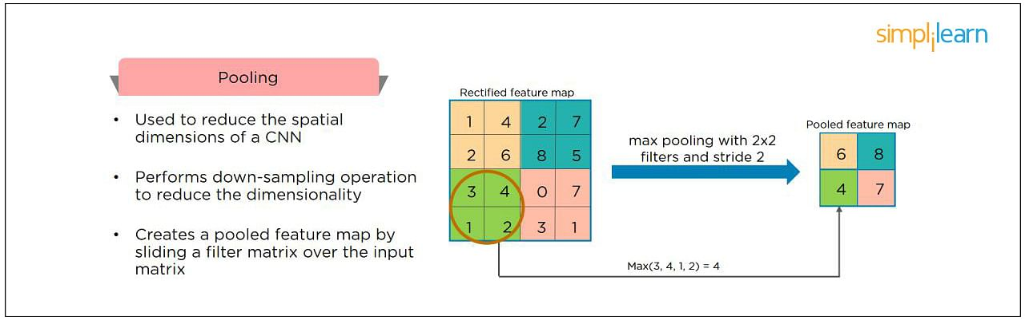

21. How Does an LSTM Network Work?

Long-Short-Term Memory (LSTM) is a special kind of recurrent neural network capable of learning long-term dependencies, remembering information for long periods as its default behavior. There are three steps in an LSTM network:

* Step 1: The network decides what to forget and what to remember.
* Step 2: It selectively updates cell state values.
* Step 3: The network decides what part of the current state makes it to the output.

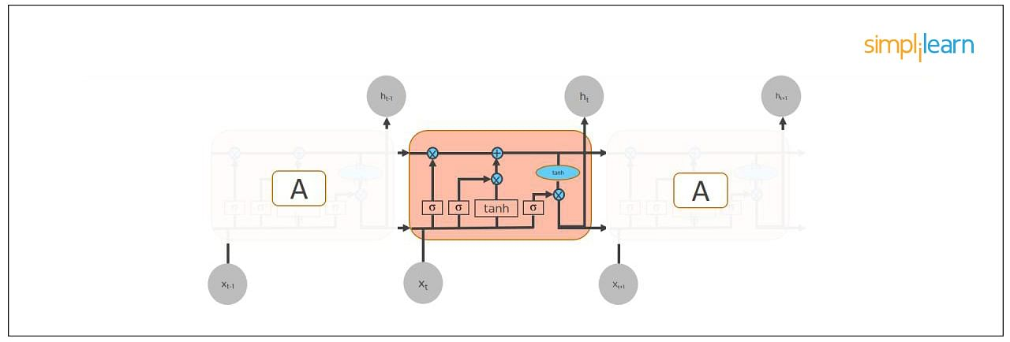

22. What Are Vanishing and Exploding Gradients?

While training an RNN, your slope can become either too small or too large; this makes the training difficult. When the slope is too small, the problem is known as a “Vanishing Gradient.” When the slope tends to grow exponentially instead of decaying, it’s referred to as an “Exploding Gradient.” Gradient problems lead to long training times, poor performance, and low accuracy.

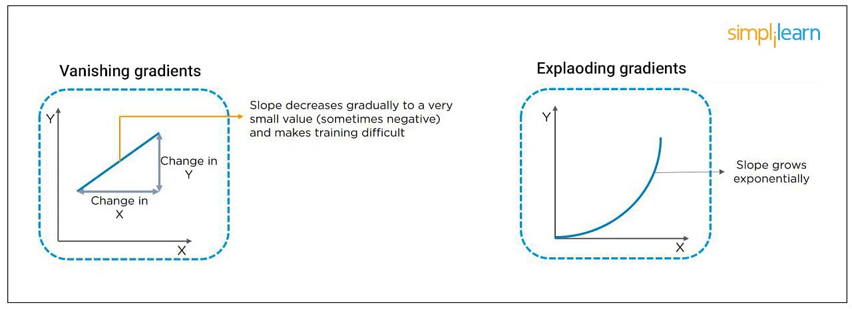

23. What Is the Difference Between Epoch, Batch, and Iteration in Deep Learning?

* Epoch - Represents one iteration over the entire dataset (everything put into the training model).
* Batch - Refers to when we cannot pass the entire dataset into the neural network at once, so we divide the dataset into several batches.
* Iteration - if we have 10,000 images as data and a batch size of 200. then an epoch should run 50 iterations (10,000 divided by 50).

24. Why is Tensorflow the Most Preferred Library in Deep Learning?

[Tensorflow](https://www.simplilearn.com/tutorials/deep-learning-tutorial/what-is-tensorflow) provides both [C++](https://www.simplilearn.com/tutorials/cpp-tutorial/learn-cpp-basics) and Python APIs, making it easier to work on and has a faster compilation time compared to other Deep Learning libraries like [Keras and Torch](https://www.simplilearn.com/keras-vs-tensorflow-vs-pytorch-article). Tensorflow supports both CPU and GPU computing devices.

25. What Do You Mean by Tensor in Tensorflow?

This is another most frequently asked deep learning interview question. A tensor is a mathematical object represented as arrays of higher dimensions. These arrays of data with different dimensions and ranks fed as input to the neural network are called “Tensors.”

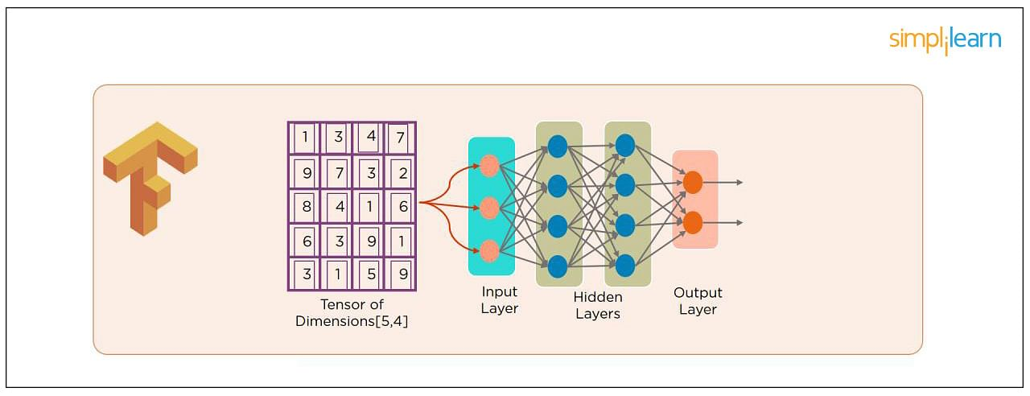

26. What Are the Programming Elements in Tensorflow?

Constants - Constants are parameters whose value does not change. To define a constant we use  tf.constant() command. For example:

a = tf.constant(2.0,tf.float32)

b = tf.constant(3.0)

Print(a, b)

Variables - Variables allow us to add new trainable parameters to graph. To define a variable, we use the tf.Variable() command and initialize them before running the graph in a session. An example:

W = tf.Variable([.3].dtype=tf.float32)

b = tf.Variable([-.3].dtype=tf.float32)

Placeholders - these allow us to feed data to a tensorflow model from outside a model. It permits a value to be assigned later. To define a placeholder, we use the tf.placeholder() command. An example:

a = tf.placeholder (tf.float32)

b = a*2

with tf.Session() as sess:

result = sess.run(b,feed_dict={a:3.0})

print result

Sessions - a session is run to evaluate the nodes. This is called the “Tensorflow runtime.” For example:

a = tf.constant(2.0)

b = tf.constant(4.0)

c = a+b

# Launch Session

Sess = tf.Session()

# Evaluate the tensor c

print(sess.run(c))

27. Explain a Computational Graph.

Everything in a [tensorflow](https://www.simplilearn.com/tutorials/deep-learning-tutorial/tensorflow) is based on creating a computational graph. It has a network of nodes where each node operates, Nodes represent mathematical operations, and edges represent tensors. Since data flows in the form of a graph, it is also called a “DataFlow Graph.”

28. Explain [Generative Adversarial Network.](https://www.simplilearn.com/tutorials/deep-learning-tutorial/generative-adversarial-networks-gans)

Suppose there is a wine shop purchasing wine from dealers, which they resell later. But some dealers sell fake wine. In this case, the shop owner should be able to distinguish between fake and authentic wine.

The forger will try different techniques to sell fake wine and make sure specific techniques go past the shop owner’s check. The shop owner would probably get some feedback from wine experts that some of the wine is not original. The owner would have to improve how he determines whether a wine is fake or authentic.

The forger’s goal is to create wines that are indistinguishable from the authentic ones while the shop owner intends to tell if the wine is real or not accurately.

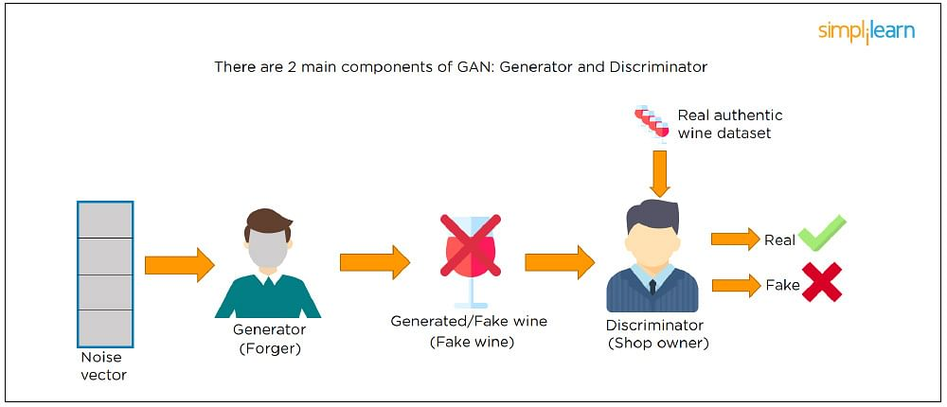

Let us understand this example with the help of an image shown above.

There is a noise vector coming into the forger who is generating fake wine.

Here the forger acts as a Generator.

The shop owner acts as a Discriminator.

The Discriminator gets two inputs; one is the fake wine, while the other is the real authentic wine. The shop owner has to figure out whether it is real or fake.

So, there are two primary components of Generative Adversarial Network (GAN) named:

1. Generator
2. Discriminator

The generator is a CNN that keeps keys producing images and is closer in appearance to the real images while the discriminator tries to determine the difference between real and fake images The ultimate aim is to make the discriminator learn to identify real and fake images.

29. What Is an Auto-encoder?

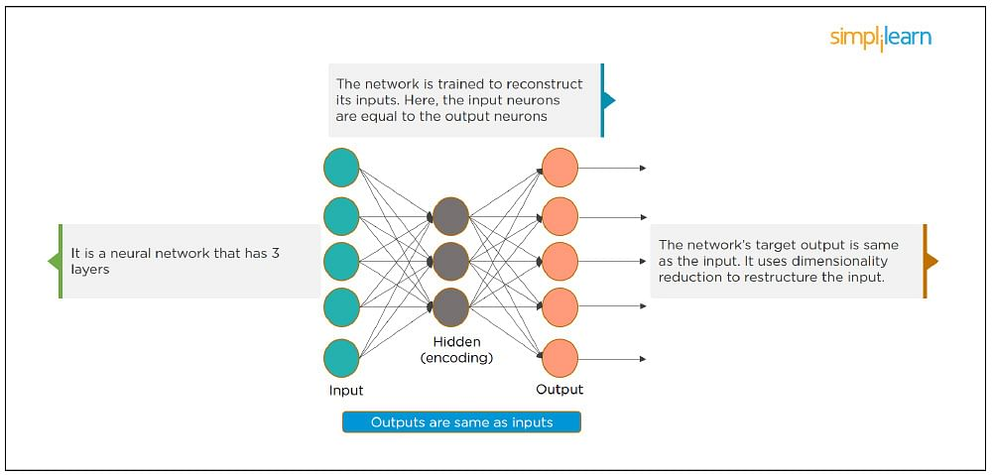

This Neural Network has three layers in which the input neurons are equal to the output neurons. The network's target outside is the same as the input. It uses dimensionality reduction to restructure the input. It works by compressing the image input to a latent space representation then reconstructing the output from this representation.

30. What Is Bagging and Boosting?

Bagging and Boosting are ensemble techniques to train multiple models using the same learning algorithm and then taking a call.

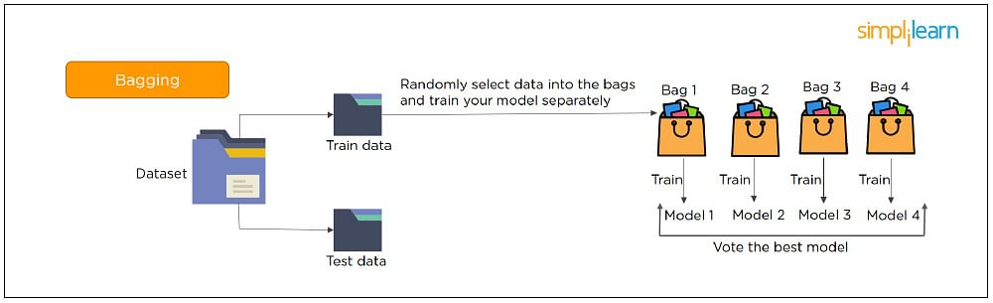

With Bagging, we take a dataset and split it into training data and test data. Then we randomly select data to place into the bags and train the model separately.

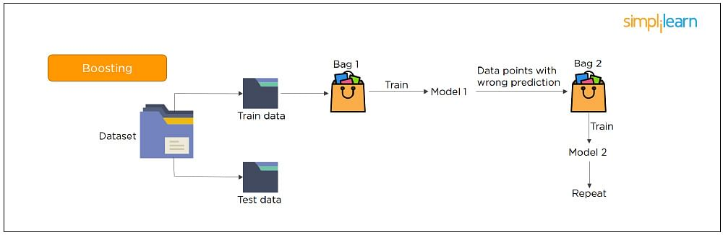

With Boosting, the emphasis is on selecting data points which give wrong output to improve the accuracy.

The following are some of the most important advanced deep learning interview questions that you should know!

31. What is the significance of using the Fourier transform in Deep Learning tasks?

The Fourier transform function efficiently analyzes, maintains, and manages large datasets. You can use it to generate real-time array data that is helpful for processing multiple signals.

32. What do you understand by transfer learning? Name a few commonly used transfer learning models.

Transfer learning is the process of transferring the learning from a model to another model without having to train it from scratch. It takes critical parts of a pre-trained model and applies them to solve new but similar machine learning problems.

Some of the popular transfer learning models are:

* VGG-16
* BERT
* GTP-3
* Inception V3
* XCeption

33. What is the difference between SAME and VALID padding in Tensorflow?

Using the Tensorflow library, tf.nn.max_pool performs the max-pooling operation. Tf.nn.max_pool has a padding argument that takes 2 values - SAME or VALID.

With padding == “SAME” ensures that the filter is applied to all the elements of the input.

The input image gets fully covered by the filter and specified stride. The padding type is named SAME as the output size is the same as the input size (when stride=1).

With padding == “VALID” implies there is no padding in the input image. The filter window always stays inside the input image. It assumes that all the dimensions are valid so that the input image gets fully covered by a filter and the stride defined by you.

34. What are some of the uses of Autoencoders in Deep Learning?

* Autoencoders are used to convert black and white images into colored images.
* Autoencoder helps to extract features and hidden patterns in the data.
* It is also used to reduce the dimensionality of data.
* It can also be used to remove noises from images.

35. What is the Swish Function?

Swish is an activation function proposed by Google which is an alternative to the ReLU activation function.

It is represented as: f(x) = x * sigmoid(x).

The Swish function works better than ReLU for a variety of deeper models.

The derivative of Swist can be written as: y’ = y + sigmoid(x) * (1 - y)

36. What are the reasons for mini-batch gradient being so useful?

* Mini-batch gradient is highly efficient compared to stochastic gradient descent.
* It lets you attain generalization by finding the flat minima.
* Mini-batch gradient helps avoid local minima to allow gradient approximation for the whole dataset.

37. What do you understand by Leaky ReLU activation function?

Leaky ReLU is an advanced version of the ReLU activation function. In general, the ReLU function defines the gradient to be 0 when all the values of inputs are less than zero. This deactivates the neurons. To overcome this problem, Leaky ReLU activation functions are used. It has a very small slope for negative values instead of a flat slope.

38. What is Data Augmentation in Deep Learning?

Data Augmentation is the process of creating new data by enhancing the size and quality of training datasets to ensure better models can be built using them. There are different techniques to augment data such as numerical data augmentation, image augmentation, GAN-based augmentation, and text augmentation.

39. Explain the Adam optimization algorithm.

Adaptive Moment Estimation or Adam optimization is an extension to the stochastic gradient descent. This algorithm is useful when working with complex problems involving vast amounts of data or parameters. It needs less memory and is efficient.

Adam optimization algorithm is a combination of two gradient descent methodologies -

Momentum and Root Mean Square Propagation.

40. Why is a convolutional neural network preferred over a dense neural network for an image classification task?

* The number of parameters in a convolutional neural network is much more diminutive than that of a Dense Neural Network. Hence, a CNN is less likely to overfit.
* CNN allows you to look at the weights of a filter and visualize what the network learned. So, this gives a better understanding of the model.
* CNN trains models in a hierarchical way, i.e., it learns the patterns by explaining complex patterns using simpler ones.

41. Which strategy does not prevent a model from over-fitting to the training data?

1. Dropout
2. Pooling
3. Data augmentation
4. Early stopping

Answer: b) Pooling - It’s a layer in CNN that performs a downsampling operation.

42. Explain two ways to deal with the vanishing gradient problem in a deep neural network.

* Use the ReLU activation function instead of the sigmoid function
* Initialize neural networks using Xavier initialization that works with tanh activation.

43. Why is a deep neural network better than a shallow neural network?

Both deep and shallow neural networks can approximate the values of a function. But the deep neural network is more efficient as it learns something new in every layer. A shallow neural network has only one hidden layer. But a deep neural network has several hidden layers that create a deeper representation and computation capability.

44. What is the need to add randomness in the weight initialization process?

If you set the weights to zero, then every neuron at each layer will produce the same result and the same gradient value during backpropagation. So, the neural network won’t be able to learn the function as there is no asymmetry between the neurons. Hence, randomness to the weight initialization process is crucial.

45. How can you train hyperparameters in a neural network?

Hyperparameters in a neural network can be trained using four components:

Batch size: Indicates the size of the input data.

Epochs: Denotes the number of times the training data is visible to the neural net

NLP

1. What is Natural Language Processing?

While this may sound like a softball NLP interview question, the way you answer it will clue the interviewer into how well you grasp NLP as a whole.

Natural language processing (NLP) is an automated way to understand or analyze the nuances and overall meaning of natural language, extracting key information from typed or spoken language by applying [machine learning algorithms](https://www.simplilearn.com/tutorials/deep-learning-tutorial/deep-learning-algorithm). Since meaning is largely derived from its context, NLP seeks to understand language beyond the literal and allow machines to learn through experience.

2. What is an NLP pipeline, and what does it consist of?

Generally, NLP problems can be solved by navigating the following steps (referred as a pipeline):

* Gathering text, whether it’s from web scraping or the use of available datasets
* Cleaning text (through the processes of [stemming and lemmatization](https://nlp.stanford.edu/IR-book/html/htmledition/stemming-and-lemmatization-1.html))
* Representation of the text ([bag-of-words](https://machinelearningmastery.com/gentle-introduction-bag-words-model/) method)
* Word embedding and sentence representation ([Word2Vec, SkipGram model](https://towardsdatascience.com/nlp-101-word2vec-skip-gram-and-cbow-93512ee24314))
* Training the model (via [neural nets](https://www.simplilearn.com/tutorials/deep-learning-tutorial/neural-network) or regression techniques)
* Evaluating the model
* Adjusting the model, as needed
* Deploying the model

3. What does “parsing” mean in the world of NLP?

To “parse” a document, in the context of NLP, is to make sense of its grammatical structure. For example, an NLP application parses text by determining the relationship of words and phrases within the text (e.g., which words are the subject, or object, of a given verb?). [Parsing](https://forum.huawei.com/enterprise/en/what-is-parsing-in-nlp/thread/571685-100429#:~:text=Simply%20speaking%2C%20parsing%20in%20NLP,%E2%80%9CTom%20ate%20an%20apple%E2%80%9D.) will differ from one set of text to another, since its goal is to understand the grammar and what the writer or speaker is trying to convey.

4. What is “named entity recognition”?

This will likely be one of the NLP interview questions you will get. Named entity recognition (NER) is an NLP process that separates out the components of a sentence to summarize it into its main components, similar to sentence diagramming in grade school. For example, the sentence “Bob moved to New York City in 1997” may be categorized as:

* Bob = name
* New York City = city/location
* 1997 = time

NER helps machines understand the context of the document by identifying data related to “who, what, when, and where.” It’s very useful for scanning documents and responding to [chatbots](https://www.simplilearn.com/ai-and-chatbots-article) in a customer service environment.

5. What is a “stop” word?

Articles such as “the” or “an,” and other filler words that bind sentences together (e.g., “how,” “why,” and “is”) but don’t offer much additional meaning are often referred to as “stop” words. In order to get to the root of a search and deliver the most relevant results, search engines routinely filter out stop words.

6. What is “feature extraction” and how is it accomplished using NLP?

The process of [feature extraction](https://deepai.org/machine-learning-glossary-and-terms/feature-extraction#:~:text=Feature%20extraction%20is%20the%20name,describing%20the%20original%20data%20set.) involves the identification of certain key words or phrases that put it into a particular category, often based on the author’s purported sentiment. For example, a product review by a customer that uses the word “great” or the phrase “good quality” could be summarized as a positive review. The feature extraction process in NLP could enable a given phrase or use of certain words to be “tokenized” into the positive review category.

7. How do you test an NLP model? What metrics are used?

NLP models should be tested for accuracy, but also must consider the likelihood of false positives and false negatives due to the complexity and nuances of language. Therefore, while accuracy is important, you also want to [test an NLP model](https://towardsdatascience.com/accuracy-precision-recall-or-f1-331fb37c5cb9) using the following metrics:

* Recall. This is expressed by the following equation:

True Positive / True Positive + False Negative = True Positive / Total Actual Positive

* Precision. This is expressed by the following equation:

True Positive / True Positive + False Positive = True Positive / Total Predicted Positive

* F1. This is a combination of recall and precision and is expressed by the following equation:

F1 = 2X Precision * Recall / Precision + Recall

8. What are two applications of NLP used today?

There are several real-world NLP applications in use today, including:

* Chatbots: Chatbots (powered by NLP) are often the starting point for customer service interactions, designed to resolve basic customer queries and funnel them to the right personnel if the chatbot is unable to provide resolution. These provide efficiency and cost savings for companies.
* Online translation: Services such as Google Translate use NLP to convert both written and spoken language into other languages and can also help with pronunciation.

9. What is “term frequency-inverse document frequency?”

Term frequency-inverse document frequency ([TF-IDF](http://www.tfidf.com/)) is an indicator of how important a given word is in a document, which helps identify key words and assist with the process of feature extraction for categorization purposes. While “TF” identifies how frequently a given word or phrase (“W”) is used, “IDF” measures its importance within the document. The formulas to answer this NLP interview question are as follows:

* TF(W) = Frequency of W in a document / Total number of terms in the document
* IDF(W) = log_e (Total number of documents / Number of documents having the term W)

Using these formulas, you can determine just how important a given word or phrase is within a document. If the TF-IDF is high, then the frequency of that term is lower; if the TF-IDF is low, then its frequency is higher. Search engines use this to help them rank sites.

10. What is “latent semantic indexing?”

Undoubtedly, this will be one of the NLP interview questions that you will be asked: What is latent semantic indexing? Latent semantic indexing (LSI) is used to extract useful information from unstructured data by identifying different words and phrases that have the same or similar meanings within a given context. It’s a mathematical method for determining context and obtaining a deeper understanding of the language, [widely used by search engines](https://www.simplilearn.com/tutorials/seo-tutorial/how-to-do-keyword-research).

11. What is NLTK?

NLTK (Natural Language Toolkit) is a powerful open-source library for Python programming language that provides a comprehensive suite of libraries and tools for natural language processing (NLP) tasks. It is widely used for teaching, research, and development in NLP.

NLTK includes various modules for text processing, stemming, tokenization, parsing, tagging, machine learning, and semantic reasoning techniques. These modules can process raw text and extract meaningful insights and patterns.

With NLTK, users can perform sentiment analysis, text classification, named entity recognition, part-of-speech tagging, and more. NLTK's extensive documentation and active community make it easy to learn and use. It is also compatible with popular [Python libraries](https://www.simplilearn.com/top-python-libraries-for-data-science-article) like Matplotlib, Scikit-learn, and Pandas, making it a versatile tool for [data analysis](https://www.simplilearn.com/data-analysis-methods-process-types-article) and visualisation in NLP.

12. What is Syntactic Analysis?

[Syntactic analysis](https://www.simplilearn.com/semantic-vs-syntactic-keyword-article) is the process of analysing a sentence's syntax or grammatical structure. It involves identifying the different components of a sentence, such as nouns, verbs, adjectives, and adverbs, as well as the relationships between them.

The goal of syntactic analysis is to understand how words are combined in a sentence and how the grammatical rules of a language are used to create meaning. This involves identifying the grammatical function of each word and how it relates to the other words in the sentence.

Syntactic analysis is an integral part of natural language processing (NLP) and is used in a variety of applications such as machine translation, text-to-speech conversion, and chatbots. By understanding the structure of a sentence, computers can better understand the meaning of a text and generate more accurate and meaningful responses.

13. What is Semantic Analysis?

Semantic analysis, also known as natural language processing (NLP), is a branch of computer science that focuses on interpreting human language. It involves using algorithms and techniques to understand the meaning of a text's words, phrases, and sentences.

The semantic analysis aims to enable computers to understand human language in a way that is similar to how people understand it. This involves recognising the individual words in a sentence and understanding the relationships between them and the context in which they are used.

Semantic analysis is used in an array of applications, including sentiment analysis, machine translation, search engines, chatbots, and so on. It is also used in fields such as customer service, marketing, and social media analysis, where understanding the meaning behind human language is crucial for success.

14. List the Components of Natural Language Processing.

The components of Natural Language Processing (NLP) are:

* Text Preprocessing: This involves the cleaning and preparation of the raw text data for further analysis. This may include tokenization, stopword removal, stemming or lemmatization, and part-of-speech tagging.
* Morphological Analysis: This component studies words' internal structure and forms. This may include morpheme segmentation, inflectional morphology, and derivational morphology.
* Syntactic Analysis: This involves the study of the grammatical structure of sentences and the relationships between words. This may include tasks such as parsing, dependency analysis, and constituency analysis.
* Semantic Analysis: This component deals with the meaning of words and sentences. This may include named entity recognition, word sense disambiguation, and semantic role labelling.
* Discourse Analysis: This involves the study of larger units of language beyond the sentence level, such as paragraphs or entire documents. This may include tasks such as text coherence and cohesion analysis.
* Pragmatic Analysis: This component deals with studying the use of language in context and how it is affected by the speaker's intentions, beliefs, and assumptions. This may include speech act recognition, sentiment analysis, and emotion detection.

The abovementioned components work together to enable machines to process, understand, and generate human language.

15. What are Regular Expressions?

Regular expressions, often abbreviated as "regex," are patterns used to match and manipulate strings of text. They are a powerful tool for searching, replacing, and manipulating text data. Regular expressions can be used in a wide variety of [programming languages](https://www.simplilearn.com/best-programming-languages-start-learning-today-article), text editors, and other software tools to perform complex text operations with a single command.

Regular expressions are built from a combination of literal and special characters or metacharacters with specific meanings. For example, the period character "." matches any single character, while the asterisk character "*" matches zero or more occurrences of the preceding character or group.

Regular expressions can validate input, extract data, transform strings, and perform many other text-processing tasks. They are handy for working with large amounts of unstructured text data, such as log files or emails, where manual processing would be time-consuming or error-prone.

While regular expressions can be powerful, they can also be complex and difficult to understand or debug. As such, they require some learning and practice to use effectively.

16. What is Regular Grammar?

A regular grammar is a formal grammar that generates a regular language, a type of formal language that can be recognised by a finite-state automaton, such as a DFA (deterministic finite automaton) or an NFA (non-deterministic finite automaton).

Regular grammar consists of a set of production rules, each of which has one of the following forms:

* A → aB or A → a, where A and B are non-terminal symbols and a is a terminal symbol.
* A → ε, where A is a non-terminal symbol and ε represents the empty string.

In regular grammar, the right-hand side of each production rule consists of either a single terminal symbol or a non-terminal symbol followed by a single terminal symbol. This restriction means that regular grammars are less powerful than other types of grammar, such as context-free grammar. Still, they are simpler to analyse and more amenable to automatic parsing and generation.

Regular grammar is commonly used in programming languages, text editors, and other software tools to specify patterns for matching and manipulating strings of text, often using regular expressions. They are also crucial in theoretical computer science, where they form the basis for many important concepts and algorithms in automata theory, formal language theory, and computational complexity theory.

17. Explain Dependency Parsing in NLP.

Dependency parsing is a technique in natural language processing (NLP) that involves analysing the grammatical structure of a sentence to determine the relationships between words. Specifically, it involves identifying the dependency relationships between words in a sentence, where a dependency relationship represents the grammatical relationship between a headword and its dependencies.

In a dependency tree, each word in the sentence is represented by a node, and directed edges represent their dependency relationships. The head of a dependency relationship is the word that the dependent modifies or describes, while the dependent is the word modified or described by the head.

Several algorithms and techniques for performing dependency parsing, ranging from rule-based to statistical and machine-learning-based approaches. These techniques typically involve analysing the syntactic and semantic features of the sentence, such as part-of-speech tags, word embeddings, and contextual information, to predict the most likely dependency structure.

Dependency parsing has a wide range of applications in NLP, including information extraction, question answering, sentiment analysis, and machine translation. It can also improve the performance of other NLP tasks, such as named entity recognition and text classification, by providing additional contextual information about the relationships between words in a sentence.

18. What is the Difference between NLP and NLU?

NLP and NLU are two closely related fields in artificial intelligence (AI) that deal with processing and understanding natural language.

NLP (Natural Language Processing) refers to using computational techniques to analyse and generate human language. It encompasses a broad range of tasks, such as text classification, language translation, sentiment analysis, and information retrieval.

On the other hand, NLU (Natural Language Understanding) is a subfield of NLP that focuses on understanding the meaning of human language. It involves comprehending the semantic relationships between words and extracting the underlying meaning from a piece of text. NLU aims to teach machines how to understand the nuances of human language by using techniques like entity recognition, semantic parsing, and sentiment analysis.

NLP deals with the broad processing of natural language, while NLU deals with the more specific task of understanding the meaning of natural language.

19. What is the Difference between NLP and CI?

NLP and CI are related to artificial intelligence but have different goals and applications.

NLP stands for Natural Language Processing, a field of AI focusing on the interaction between computers and human language. NLP aims to enable computers to understand, interpret, and generate natural language. Some of the applications of NLP include language translation, sentiment analysis, speech recognition, and chatbots.

On the other hand, CI stands for Computational Intelligence, a field of AI that focuses on developing algorithms and models that can learn from data and make decisions. CI aims to enable computers to perform tasks that usually require human intelligence, such as pattern recognition, optimisation, and prediction. Some of the applications of CI include data mining, machine learning, and evolutionary computation.

In summary, NLP is a subfield of AI that focuses on language-related tasks, while CI is a broader field that encompasses a wide range of AI techniques for solving complex problems.

20. What is Pragmatic Analysis?

Pragmatic analysis in natural language processing (NLP) studies how people use language in context to achieve specific communicative goals. Pragmatics deals with how people use language to convey meaning beyond the literal interpretation of words and phrases. It involves analysing the social, cultural, and situational factors influencing language use and interpretation.

Pragmatic analysis in NLP involves developing algorithms and models that can automatically analyse and understand the pragmatics of natural language. This can include tasks such as identifying speech acts (e.g. requests, commands, questions), detecting implicatures (meaning conveyed indirectly), and determining the intended meaning of an utterance based on context and background knowledge.

The pragmatic analysis is a vital area of NLP because it enables machines to understand language in a more human-like way, which can improve the accuracy and naturalness of language processing systems. For example, a virtual assistant capable of understanding the intended meaning behind a user's request can provide more accurate and helpful responses.

21. What is Pragmatic Ambiguity?

Pragmatic ambiguity in Natural Language Processing (NLP) refers to the situation where the meaning of a sentence or phrase is unclear or ambiguous because of the context in which it is used rather than due to any inherent ambiguity in the sentence structure or the meanings of individual words. In other words, ambiguity arises from how the sentence is used and interpreted in a particular context.

For example, consider the sentence, "I saw her duck". With additional context, whether the speaker saw the woman's duck (verb) or a duck belonging to her (noun) is clear. The sentence's meaning can only be determined from the context in which it is used. If the preceding sentence was "She has a pet duck", then the meaning is likely to be the latter interpretation. However, if the preceding sentence was "She performed a dive in the pool, " the meaning is likely to be the former interpretation.

Pragmatic ambiguity can be challenging for NLP systems to handle because it requires a deep understanding of the context in which the sentence is used, as well as the ability to reason about the multiple possible interpretations of the sentence.

22. What are Unigrams, Bigrams, Trigrams, and N-grams in NLP?

In Natural Language Processing (NLP), unigrams, bigrams, trigrams, and N-grams are different types of text tokens used to represent the frequency of words or sequences of words in a given corpus of text.

* Unigrams: A unigram is a word in a text corpus. For example, in the sentence "I love to play football", the unigrams are "I", "love", "to", "play", and "football".
* Bigrams: A bigram is a sequence of two adjacent words that occur together in a text corpus. For example, in the same sentence, "I love to play football", the bigrams are "I love", "love to", "to play", and "play football".
* Trigrams: A trigram is a sequence of three adjacent words that occur together in a text corpus. For example, in the same sentence, "I love to play football", the trigrams are "I love to", "love to play", and "to play football".
* N-grams: An N-gram is a sequence of N adjacent words that occur together in a text corpus. The value of N can be any positive integer, although unigrams, bigrams, and trigrams are the most commonly used. For example, a 4-gram in the sentence "I love to play football" would be "I love to play".

N-grams are often used in language modelling and text classification tasks in NLP. By counting the frequency of occurrence of different N-grams in a corpus of text, we can gain insights into the language patterns and structures in the text, which can then be used to develop models for various NLP tasks.

23. What are the Steps Involved in Solving an NLP Problem?

Solving an NLP (Natural Language Processing) problem involves several steps. Here is a general overview of the steps involved:

* Define the problem: The first step is to define the NLP problem you want to solve. This could be anything from sentiment analysis to text classification, text generation, named entity recognition, and more.
* Gather data: The second step is to gather data for your problem. This may involve scraping websites, collecting data from databases, or using pre-existing datasets.
* Preprocess data: The third step is to preprocess the data. This includes cleaning and transforming the data, such as removing stop words, stemming, lemmatization, and converting text to lowercase.
* Feature extraction: The fourth step is to extract relevant features from the preprocessed data. This may involve using techniques such as bag-of-words, TF-IDF, word embeddings, and more.
* Model training: The fifth step is to train a machine learning model on the extracted features. This may involve using algorithms such as Naive Bayes, SVM, Random Forest, or deep learning models like LSTM, Transformer, etc.
* Model evaluation: The sixth step is to evaluate the model's performance on the test dataset. This may involve using metrics such as accuracy, precision, recall, F1-score, or other relevant evaluation measures.
* Model tuning: The seventh step is to tune the model parameters to improve its performance. This may involve using [cross-validation](https://www.simplilearn.com/tutorials/machine-learning-tutorial/cross-validation), grid search, random search, or Bayesian optimisation techniques.
* Deployment: The final step is to deploy the model in a real-world application. This may involve integrating the model into a web application, mobile app, or other systems.

24. What are Precision and Recall?

Precision and recall are two common evaluation metrics used in machine learning, particularly in information retrieval and classification. They assess the quality of a model's predictions and are particularly useful in evaluating models for NLP problems.

Precision refers to the proportion of true positives (correctly classified positive examples) among all predicted positives (examples classified as positive by the model).

In other words, precision measures how often the model correctly identifies a positive example out of all the examples it predicted as positive. A high precision score indicates that the model makes few false positive errors.

In contrast, recall refers to the proportion of true positives among all actual positives in the dataset. In other words, recall measures how often the model correctly identifies a positive example out of all the positive examples in the dataset. A high recall score indicates that the model makes a few false negative errors.

In summary, Recall and precision are measures of a model's accuracy, but they focus on different aspects of the model's performance. High precision indicates that a model makes few false positive errors, while high recall indicates that a model makes few false negative errors. In practice, the choice of which metric to prioritise depends on the specific problem and the trade-offs between precision and recall that are acceptable in that context.

25. What is F1 Score in NLP?

In Natural Language Processing (NLP), the F1 score is a commonly used metric for evaluating the performance of a classification model. It measures the accuracy and completeness of a model's predictions, considering both precision and recall.

Precision measures the proportion of true positive predictions (i.e., correctly classified samples) out of all positive predictions made by the model. Recall, on the other hand, measures the proportion of true positive predictions out of all actual positive samples in the data.

The F1 score is the harmonic mean of precision and recall and is calculated as follows:

F1 = 2 * (precision * recall) / (precision + recall)

An F1 score of 1 indicates perfect precision and recall, while a score of 0 indicates that the model makes no correct predictions. In general, higher F1 scores indicate better model performance.

26. How to Tokenize a Sentence Using the NLTL Package?

NLTK (Natural Language Toolkit) is a popular Python package for natural language processing tasks. Tokenization is the procedure of breaking a sentence or a document into individual words or tokens. Here's how you can tokenize a sentence using the NLTK package:

First, you must install NLTK using the command !pip install nltk if you still need to install it.

Next, you can import the nltk module and download the necessary data by running the following code:

import nltk

nltk.download('punkt')

Now that you have the nltk module and the necessary data, you can tokenize a sentence using the word_tokenize() function, which is part of the nltk.tokenize module. Here's an example:

from nltk.tokenize import word_tokenize

sentence = "Tokenization is breaking a sentence or a document into individual words or tokens."

tokens = word_tokenize(sentence)

print(tokens)

Output:

['Tokenization', 'is', 'the', 'process', 'of', 'breaking', 'a', 'sentence', 'or', 'a', 'document', 'into', 'individual', 'words', 'or', 'tokens', '.']

As you can see, the word_tokenize() function has broken down the sentence into individual words or tokens, including punctuation.

27. Explain Stemming with the Help of an Example.

Stemming is the procedure of reducing inflected words to their root or base form. This is often done to normalise text for natural language processing tasks such as text classification or information retrieval. For example, the words "running", "runner", and "runs" all have the same root word, "run".

Here's an example of how stemming works using the Porter stemming algorithm, one of the most commonly used stemming algorithms:

Original words: run, runs, running, runner

Stemmed words: run, run, run, runner

As you can see, all words have been reduced to their base form, "run". This can be useful for applications that need to identify a word's root without considering its specific form, such as when searching a database of documents for all occurrences of a particular word regardless of its tense or other variations.

28. Explain Lemmatization with the Help of an Example.

Stemming is reducing words to their base or root form, allowing word variations to be treated as the same word. For example, the words "jumping," "jumps," and "jumped" are all variations of the base word "jump." We can identify these words as the same word by stemming them to their root form.

Let's take the example sentence: "The cat is jumping over the fence."

Using stemming, we can reduce the words to their root form as follows:

* "The" remains as it is since it is a stop word.
* "cat" remains as it is since it is already in its base form.
* "is" remains as it is since it is a stop word.
* "jumping" is stemmed to "jump"
* "over" remains as it is since it is a stop word.
* "the" remains as it is since it is a stop word.

"fence" remains as it is since it is already in its base form.

So the stemmed version of the sentence becomes: "The cat jump over the fence."

As you can see, stemming allows us to reduce the words to their base form and treat variations of the same word as one. This is useful in natural language processing tasks such as information retrieval, text mining, and sentiment analysis.

9. What is Parts-of-Speech Tagging?

Parts-of-speech tagging, or POS tagging, is analysing a text and assigning each word a part of speech based on its role in the sentence. Parts of speech refer to the grammatical categories that words are classified into, such as nouns, verbs, adjectives, adverbs, pronouns, prepositions, conjunctions, and interjections.

POS tagging is fundamental in natural language processing (NLP) tasks, such as text classification, sentiment analysis, machine translation, and information retrieval. The tagging process is typically done using a computational model, such as a statistical model or a neural network, trained on a large corpus of text data.

POS tagging is vital because it helps computers understand the meaning of a text by identifying the grammatical structure of sentences. This allows machines to perform more sophisticated analyses, such as identifying the subject and object of a sentence, or recognising patterns in using certain parts of speech.

30. How to Check Word Similarity Using the Spacy Package?

Spacy is a popular Python package for Natural Language Processing (NLP) tasks. It provides an efficient way to perform word similarity using its built-in models.

To check the similarity between two words using the Spacy package, you can follow these steps:

* Install the Spacy package using pip:

pip install spacy

* Download the Spacy model you want to use. For example, you can download the default English model using the following command:

python -m spacy download en_core_web_sm

* Load the Spacy model using the 'load' method:

word1 = nlp("apple")

word2 = nlp("banana")

similarity_score = word1.similarity(word2)

print(similarity_score)

import spacy

nlp = spacy.load('en_core_web_sm')

* Use the 'similarity' method to get the similarity score between two words:

word1 = nlp("apple")

word2 = nlp("banana")

similarity_score = word1.similarity(word2)

print(similarity_score)

The 'similarity' method returns a float value between 0 and 1, where 0 means the words are entirely dissimilar, and 1 means the words are identical in meaning.

31. What is the Naive Bayes algorithm, When can we use this algorithm in NLP?

The [Naive Bayes algorithm](https://www.simplilearn.com/tutorials/machine-learning-tutorial/naive-bayes-classifier) is a supervised machine learning technique based on the Bayes theorem. It is a probabilistic classifier frequently used in NLP applications like sentiment analysis, which pinpoints a text corpus's sentimental or emotional undertone. When previous knowledge is available, the Bayes theorem is used to calculate the probability of a hypothesis. Conditional probabilities have a role.

32. What is Text Summarization?

The challenge of writing a succinct, precise, and fluid summary of lengthier text content is known as text summarization. To better assist in discovering relevant information and consuming relevant information more quickly, approaches for automatic text summarizing are urgently needed. We require it for the reasons listed below:

* Summaries shorten reading sessions.
* Summaries facilitate the selection of documents for study.
* Indexing performance is improved via automatic summarization.
* Compared to human summarizers, automatic systems are less prejudiced.
* Because they offer individualized information, personalized summaries are helpful in question-answering systems.
* Commercial abstract services can handle more texts using automatic or semi-automatic summarizing techniques.

33. What is information extraction?

Information extraction involves taking data from unstructured text sources to locate entities, classify them, and store them in a [database](https://www.simplilearn.com/what-is-database-management-article). These items are combined with their semantic descriptions and linkages from a knowledge network using semantically enhanced information extraction, also known as a semantic annotation. This solution addresses numerous issues in business content management and knowledge discovery by adding metadata to the extracted ideas.

The technique of removing particular (pre-specified) information from text sources is known as information extraction. One of the most elementary instances is when your email extracts the information you need to put into your calendar. Legal documents, medical records, social media interactions and streams, and other freely flowing textual sources are additional sources from which structured information can be extracted.

34. What is a Bag of Words?

The bag-of-words model is one way to encode text data when analyzing text using machine learning methods. The bag-of-words method has been used to tackle problems like language modeling and document classification since it is simple to understand and use.

A bag of words is a textual illustration that shows where words appear in a manuscript. There are two components:

* A collection of well-known terms.
* A metric for the number of well-known words.

It is referred to as a "bag" of words since any details on the arrangement or structure of the words inside the document are ignored. The model doesn't care where in the document recognized terms appear; it is simply interested in whether they do.

35. What are the best NLP Tools?

* MonkeyLearn
* Aylien
* IBM Watson
* [Google Cloud](https://www.simplilearn.com/google-cloud-platform-article)
* Amazon Comprehend
* NLTK
* Stanford Core NLP
* TextBlob

36. What is NER?

Named entity recognition (NER), also known as entity chunking, extraction, or identification, is the process of locating and classifying significant pieces of data (entities) in text. Any word or group of words that constantly refers to the same item is considered an entity. Each recognized object is put into a specific category. NER machine learning (ML) models, for instance, may identify the word "super.AI" in a text and categorize it as a "Company."

Natural language processing (NLP), a branch of artificial intelligence, includes NER. NLP is concerned with the processing and analysis of natural language by computers, which refers to any language that has emerged organically instead of artificially, like coding languages.

37. What are the possible features of a text corpus in NLP?

* Word count in a document.
* The presence of a word in a document is a boolean characteristic.
* Word vector notation
* Tag: part of speech
* Dependency grammar basics.